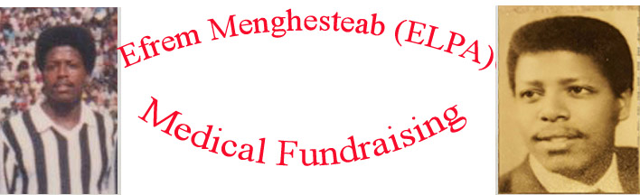
Dec 28th, 2018

Dear Sir/Madam,

We are a committee of friends, families, team mates and colleagues of Mr. Efrem Menghesteab, who is currently residing in Boston, Massachusetts with his wife and three children.

In the past eight years, Efrem fell very ill and is need of medical attention. This unfortunate sickness caused Efrem to stop working and rendered him and his family incapable of covering the medical bills that are piling up for his treatment.

As a committee, we are looking to fundraise as much as possible to help Efrem and his families pay for the medical expenses and continued treatment until full recovery.

Mr. Efrem Menghesteab was an athlete of a very high caliber. He was a Basketball and Soccer player at the highest level in Eritrea. During his youth he played Basketball with Team Adulis and in the 80s he dedicated himself to play soccer with team ELPA. In both profession he represented his country at a national level. Efrem also played a very crucial role in mentoring, coaching, and producing many youth athletes in Eritrea.

We are writing to you to support us and Efrem on this great cause. A donation of any amount can help us accomplish our goal and see Efrem recover fully. His family has already sacrificed a lot financially and emotionally and your donation will help alleviate some of the medical expenses incurred.

Thank You in advance for your contribution. This would mean a lot to us and most of all to Efrem and his whole family. Together we can make a difference!!!

Here are the ways you can donate:

- Donate online at and it is easy just a click from your fingertips,

https://www.gofundme.com/efrems-medical-fund

Thank you again!
Sincerely,

Fundraising Committee

